Social Studies Name: ________________________
Mr. Shultz Date: __________
Per: _____
LEARNING LANCASTER: STATUES
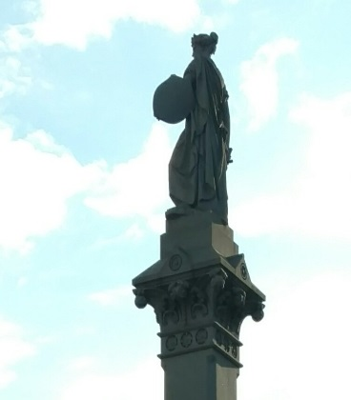
As you search for and find the various statues around Lancaster, use the following questions to deepen your knowledge. Some of the questions can be found within or around the statue itself, some may have to be explored further online, and others are just for fun.
- What is the official name of this statue?
- What happened on the spot of this statue on September 27, 1777?
- What are the eight cities/towns listed on the top portion of the statue?
- What do they have in common?
- What famous American speech can be found on this statue?
- This statue also serves as a monument for soldiers who were casualties in which wars?
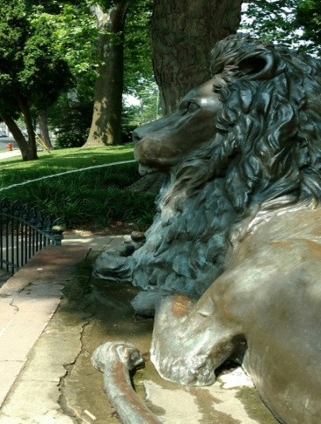
- To whom was this statue dedicated (Hint…there is a side street named after him)? Find out what this person did. What relationship is there between this person’s occupation and the brief poem written on the front of the statue?
- Around this statue are the imprints of signatures of influential Lancastrians. Who are they and what did they do?
- Approximately 100 feet to the Lion’s left is a cannon. Read the description. What happened in this story?

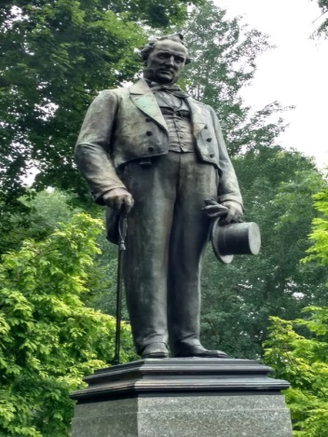
- This statue is of our 15th President, James Buchanan. While history does not look very favorably upon his presidency, some believe he may have been one of the most “qualified” people to ever serve as president. What was his political background prior to becoming President?

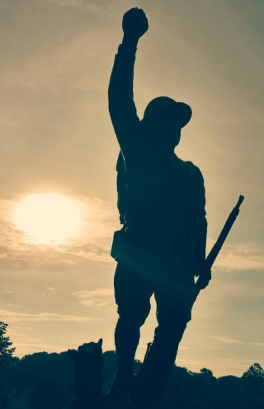
- The “Doughboy” statue is dedicated to those from Lancaster’s Seventh Ward neighborhood who served in World War One. Why is it called “doughboy”?
- There are multiple “doughboy” statues throughout the U.S., but this one is considered one of the oldest. How many are there?

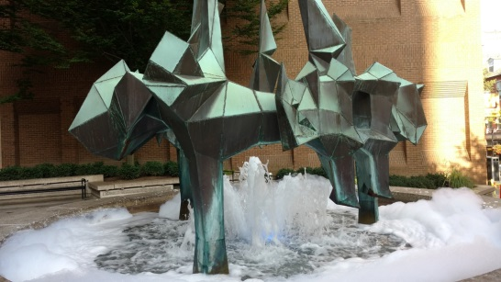
- What would you name this statue? Why?

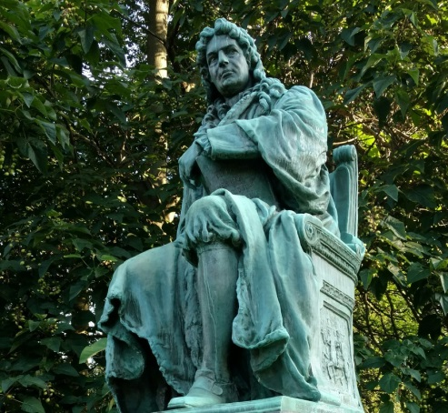
- When going past, many people confuse this person for James Buchanan. It is not. What’s his name?
- He served as the governor of which colony (hint: the name of the colony is on the book he is holding)?
- This statue is actually a replica statue. Where is the original located today?

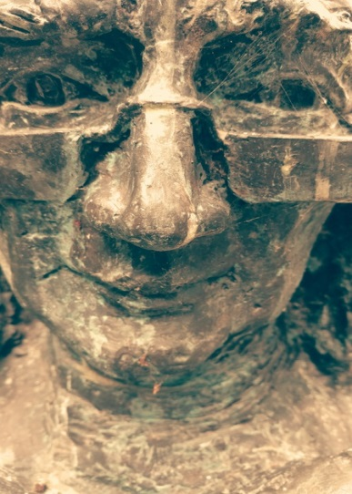
- Who is this?
- On the side of this statue are numerous quotes and sayings of this man. Which one resonates with you the most? Why?
- To the right of this statue stands a building called “Old Main”. Old Main used to be the tallest building in Lancaster. What is the tallest building now?

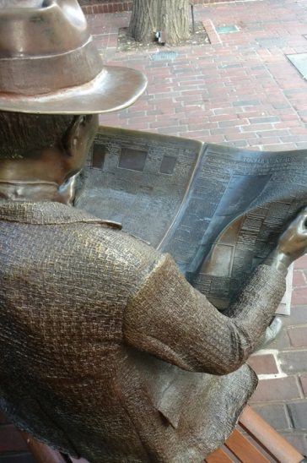
- What is the date of the newspaper he is reading?
- There are two newspapers on the bench next to him. One of the headlines deals with a major local event, the other with a major world event. What are these two events?

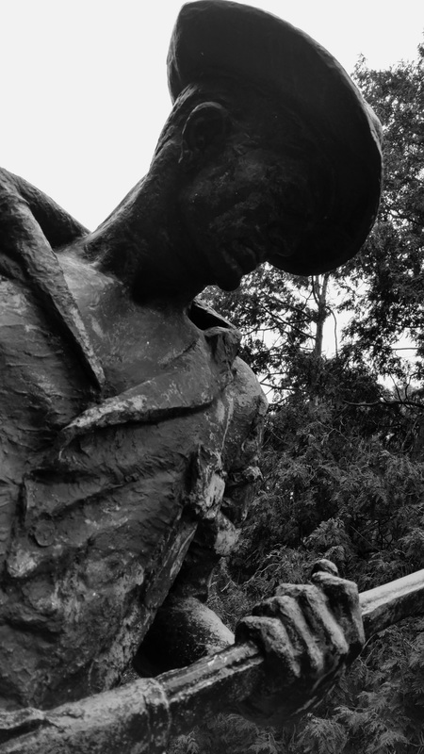
- This statue honors Lancaster veterans from which war?
- The plaques on this statue are made from metal from a famous naval ship. Which ship is it and why is the ship important to American history?
- About 100 feet in front of this statue are two memorials for Lancaster County athletes? What were their names and in which sport did each participate?

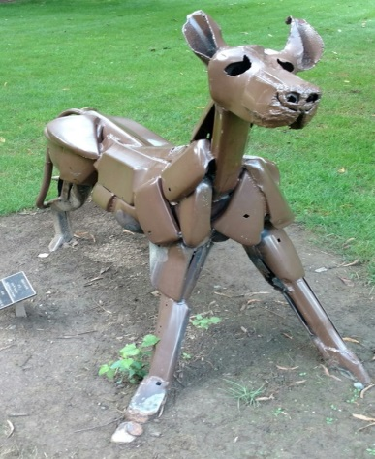
- Which type of dog is this and how old is it in dog years?

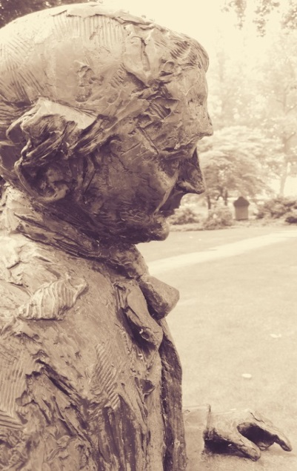
- Who is this? What important role did he have in American history?
- What is this person’s nickname? Find out why.
- Read the information on the sides of the statue. What did he have to say about slavery? What did he believe was the role of the Judiciary Branch?

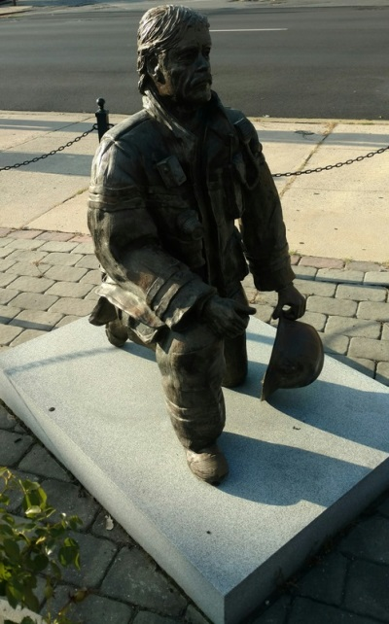
- How old is the bell in front of this man?
- This is a statue dedicated to the firefighters in Lancaster who “gave the ultimate sacrifice”. How many firefighters died on duty in Lancaster? Which of them was a firefighter the longest before their death?

- Come up with an idea for a new statue to represent a person, event, or idea in Lancaster. Where would you put it? What would it be? What would it look like? How would it honor those for which it was designed?

- Use your creativity to complete this portion of the assignment. Feel free to draw, write a letter, design a blueprint…however you feel you can express your idea the best.

